Github

# (How to add,commit | How to push from git to github | How to pull code from github)

Do SSH in your CMD

* Yum update –y (update your file)s
* Yum install git –y
* Which git ( check git is installed or not )
* git -- version

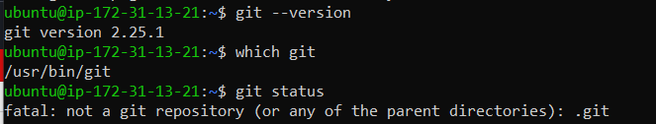

* first create a directory ,directory name is satyam
* if I want to convert a directory in repository we use this command (git init)
* we use cat command to create a new file

e.x = cat >file1, after written some data in file, enter ctrl+d to save

* we use git status to see our file
* we use **git add** command to move our file in staging area.

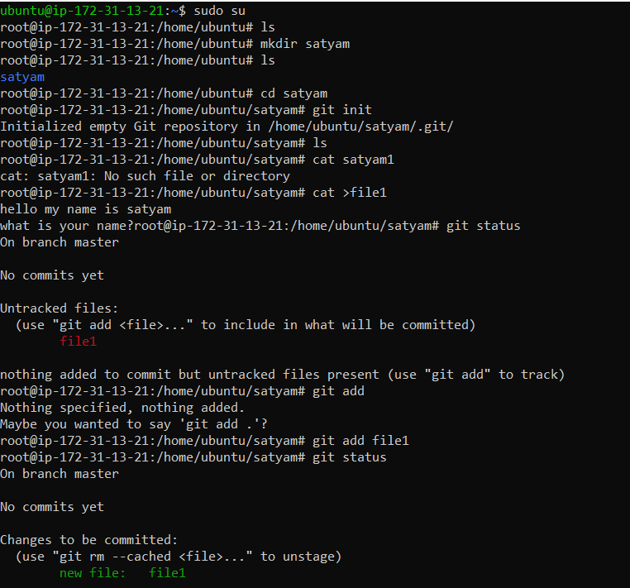

* We use **git commit –m** to move staging to production, see there are one file changed and two new file are insertion

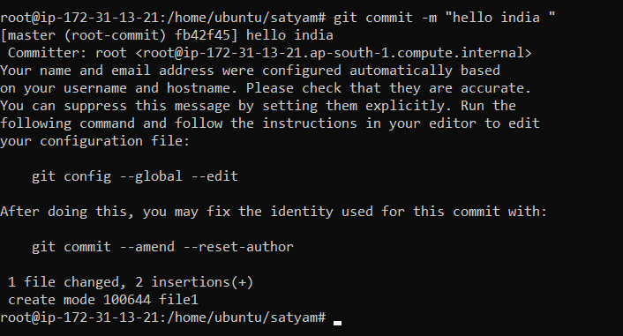

* git status commands to know in which branch you are working
* we use git log to know commit id and commit details

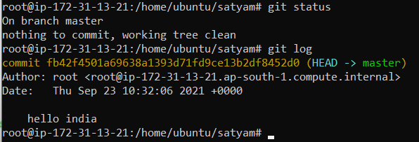

* now, we see our file is move on production server ,we see our commit id ,date and time and we also see a message hello india .

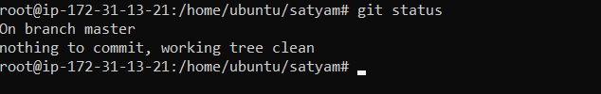

* now you see your staging area will be clean because you move your file staging to production.

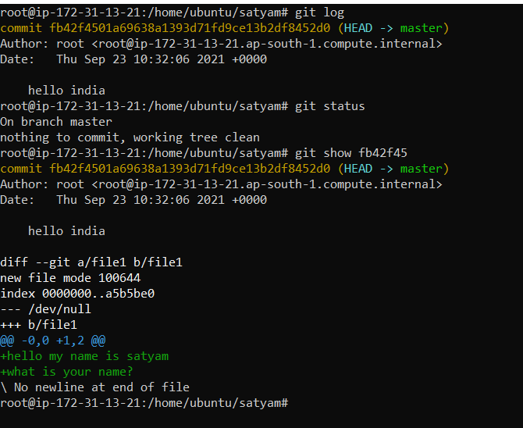

* if you want to see your file1 data you write a command

example => (git show **commit –id)**

**git show fb42f4501a69638a1393d71fd9ce13b2df8452d0**

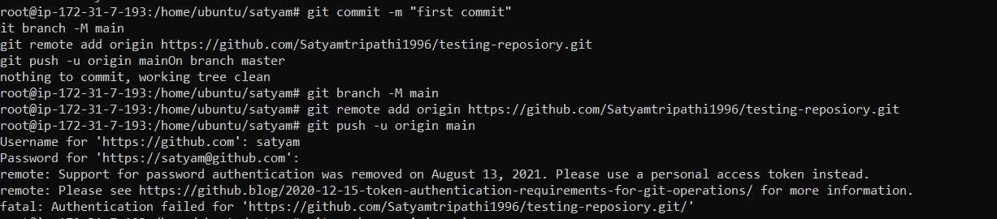

* If error come please go to this link = <https://www.theserverside.com/blog/Coffee-Talk-Java-News-Stories-and-Opinions/Fix-GitHubs-support-for-password-authentication-was-removed-error>
* 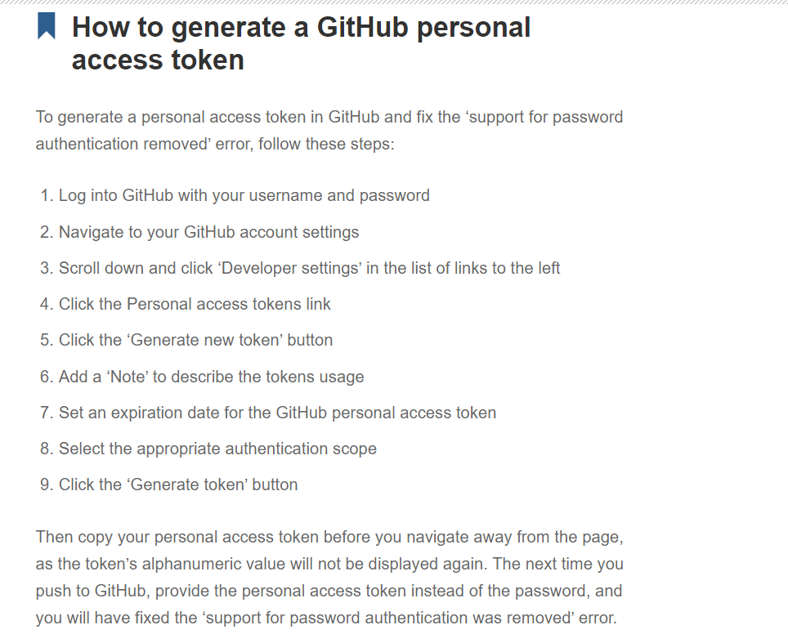

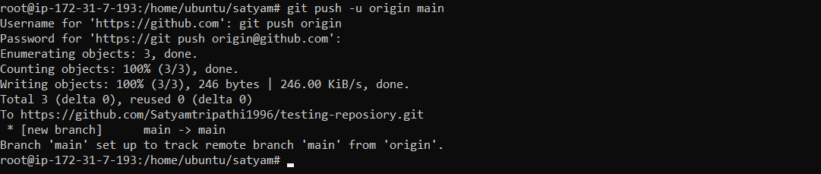

(root@ip-172-31-7-193:/home/Ubuntu/satyam# git push -u origin main)

* It means you push your file to staging in main branch

---------------------------------------------------------------------------------------------------------

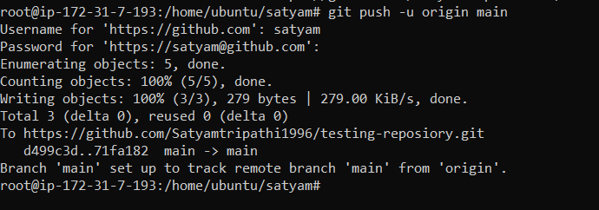

* If you change something in your local repository file and you want to commit your changes in your main github repository file ,firstly run this command
* root@ip-172-31-7-193:/home/ubuntu/satyam# **git add file1**
* root@ip-172-31-7-193:/home/ubuntu/satyam# **git commit -m file1**
* root@ip-172-31-7-193:/home/Ubuntu/satyam# git push -u origin main



* **If you don’t know password again enter your access token in password**
* **Now, go and check your main repository has been updated.**

**DONE SUCCESSFULLY**

**Ignoring files =** You can configure Git to ignore files you don't want to check in to GitHub.

You can create a .gitignore file in your repository's root directory to tell Git which files and directories to ignore when you make a commit. To share the ignore rules with other users who clone the repository, commit the .gitignore file in to your repository.

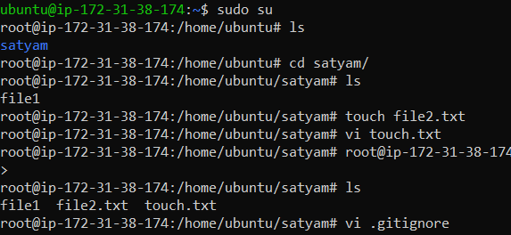

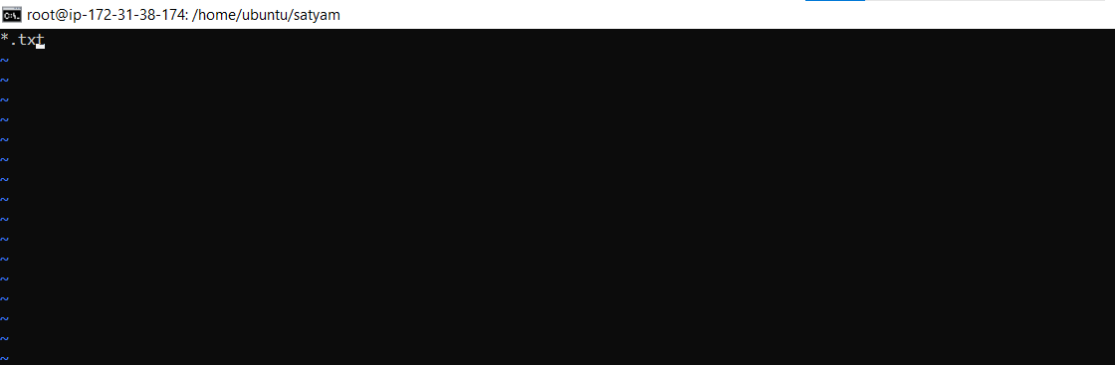

* Suppose we don't want to commit any .txt or any type of file extension so we have option to write file name or file extension in .gitignore file and save it they will ignore your file when you commit it .

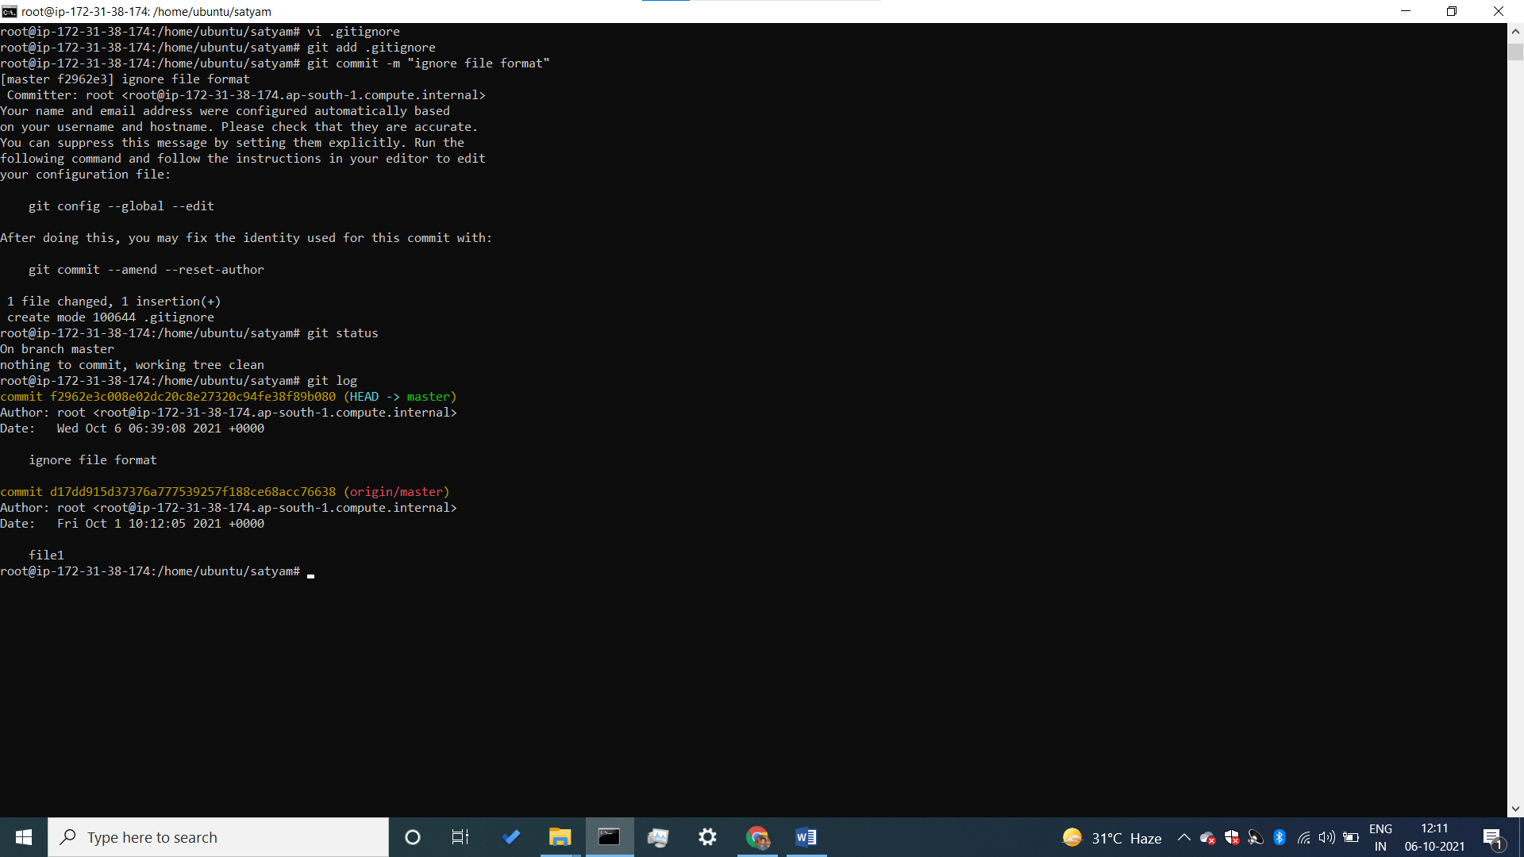

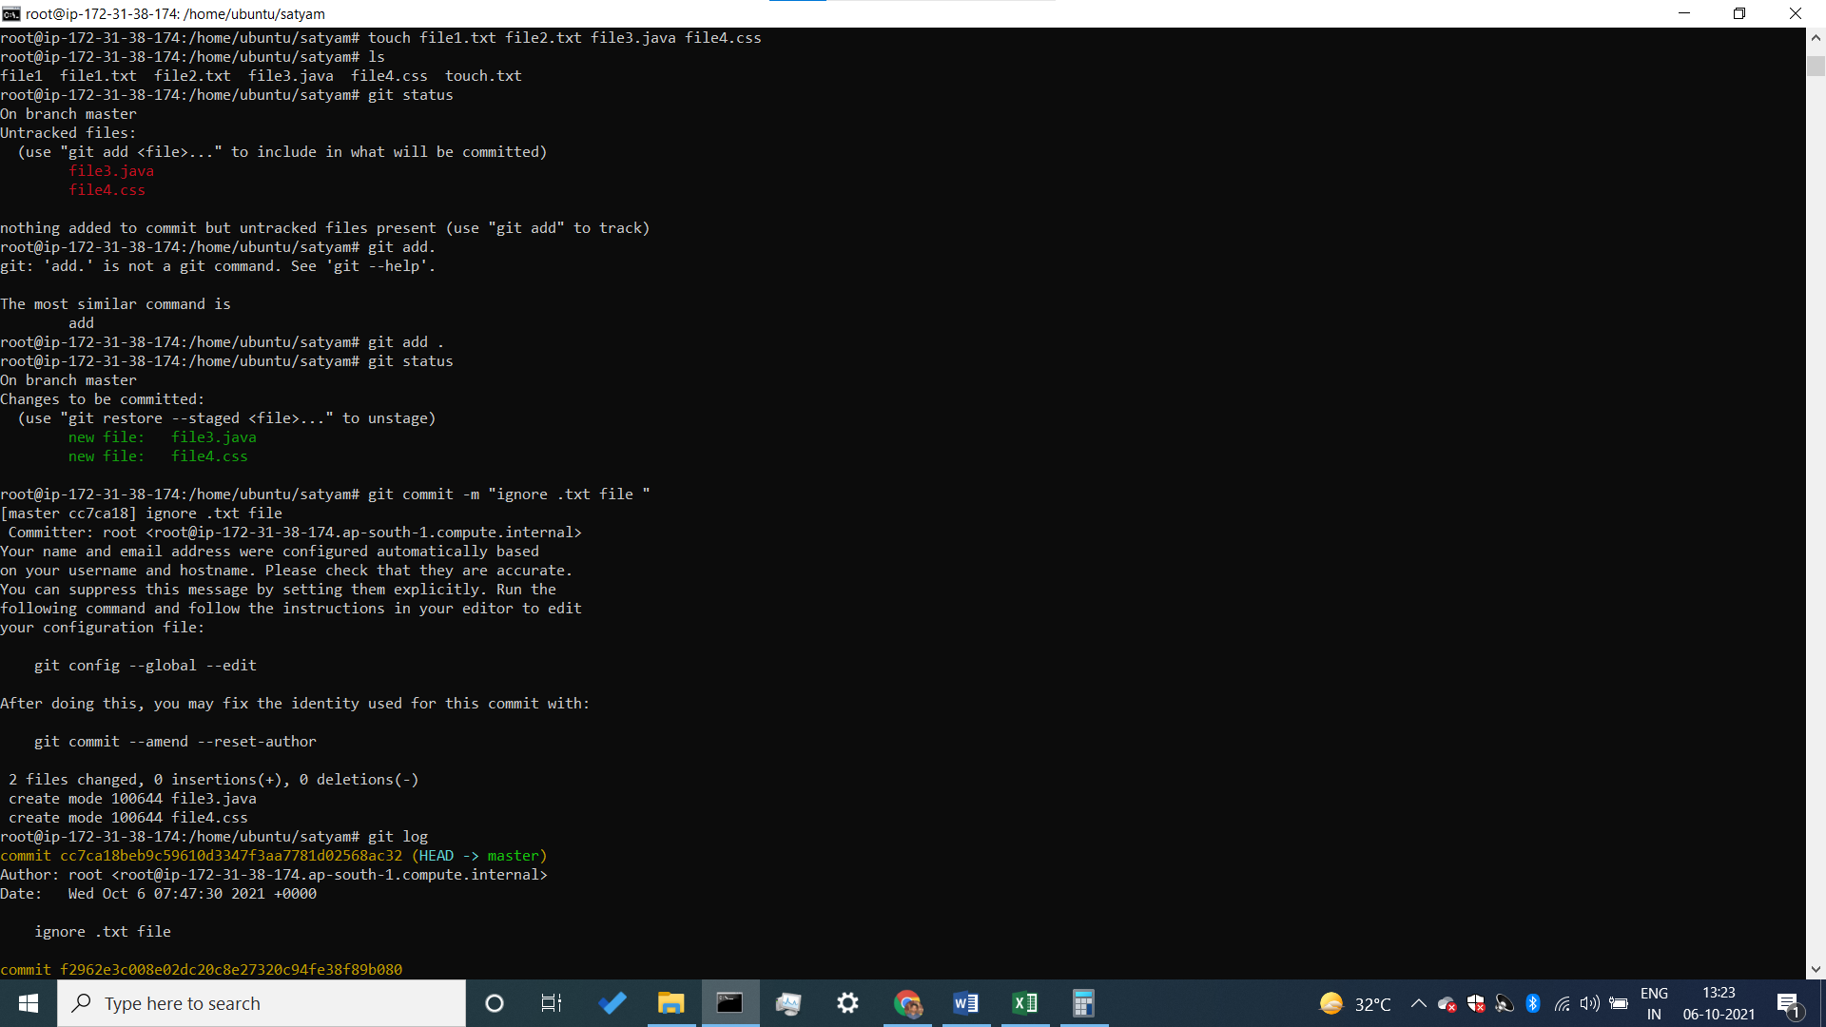

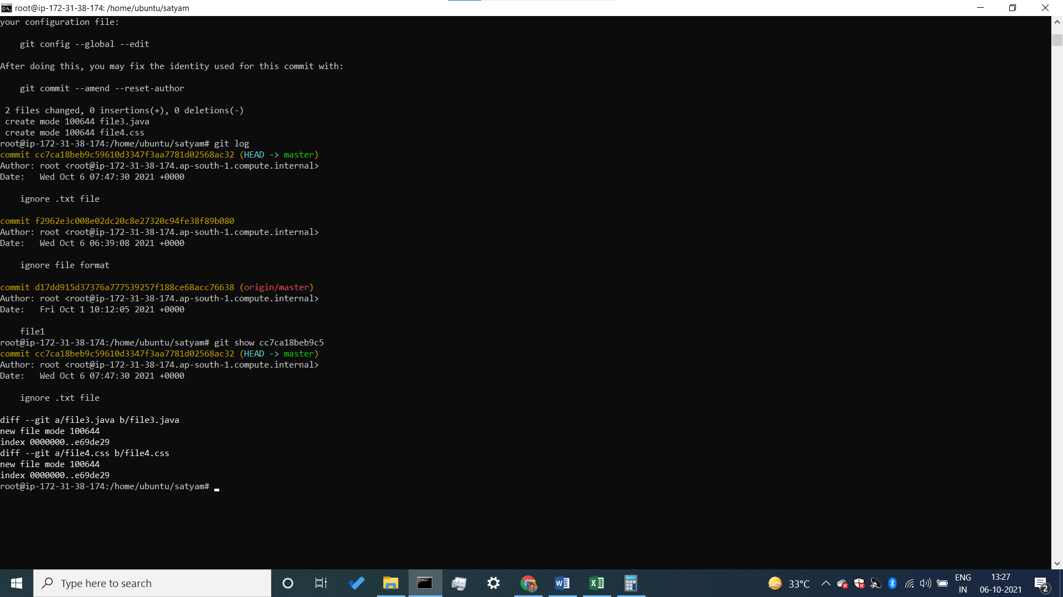

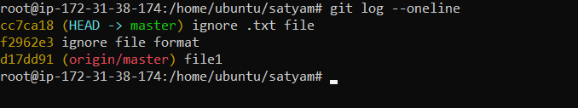

* If you want to see all commit in one line you use this command :- **root@ip-172-31-38-174:/home/ubuntu/satyam# git log --oneline**

create a username & email

* git config --global user.name “satyam”
* git config –global user.email [satyamchamptripathi@gmail.com](mailto:satyamchamptripathi@gmail.com)
* check username & email
* git config –list

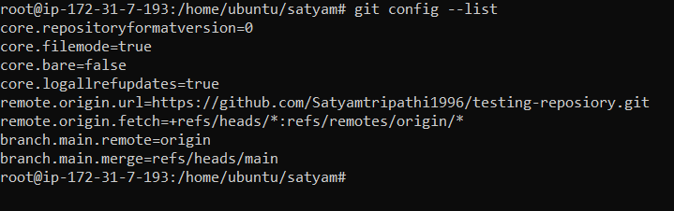

if you want to know in which branch you are working right now

* git branch

* master ( if * will come in your branch name it means you are inside this branch)

Satyam

India

If you want to create a new branch use this command

* git branch Allahabad

if you want to change your branch :-

* Git checkout Allahabad

Master

* Allahabad ( Now you are inside a Allahabad branch )